**LIBRARY MANAGEMENT**

**(AN SQL PROJECT)**

/*Display all the tables and Write the queries for the following :*/

SELECT * from Branch;

SELECT * FROM EMPLOYEE;

SELECT * FROM BOOKS;

SELECT * FROM CUSTOMER;

SELECT * from ISSUESTATUS;

SELECT * FROM RETURNSTATUS;

# 1. Retrieve the book title, category, and rental price of all available books.

SELECT BOOK_TITLE ,CATEGORY,RENTAL_PRICE FROM BOOKS;

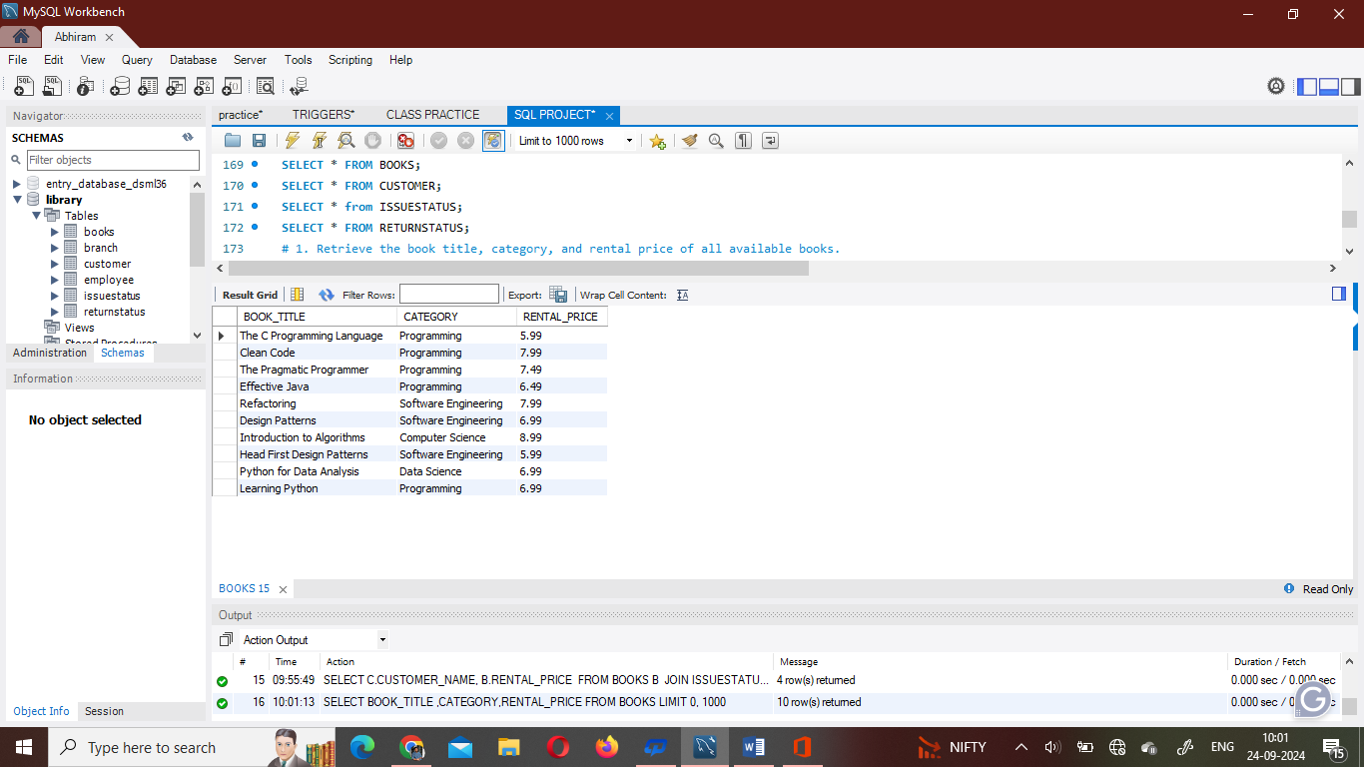

# 2. List the employee names and their respective salaries in descending order of salary.

SELECT EMP_NAME ,SALARY FROM EMPLOYEE ORDER BY SALARY DESC ;

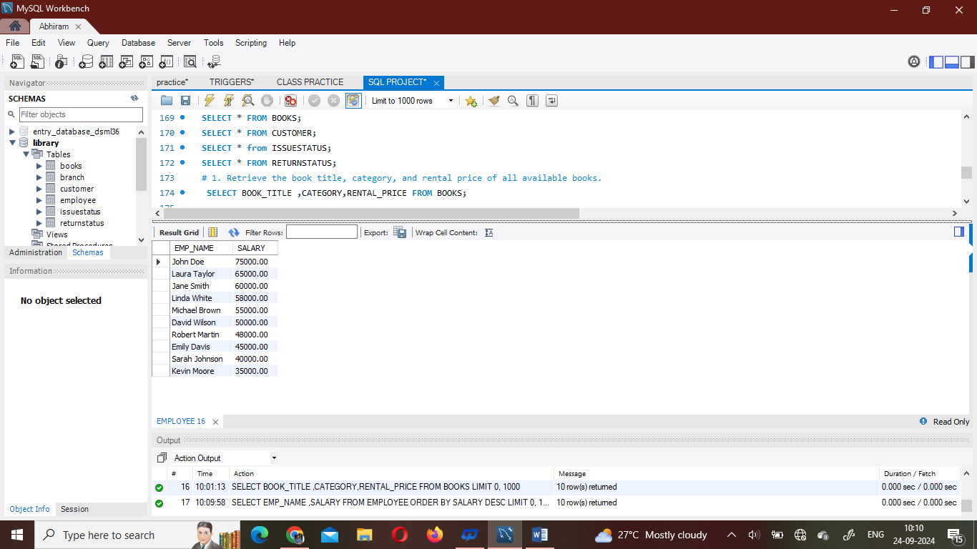

# 3. Retrieve the book titles and the corresponding customers who have issued those books.

SELECT B.BOOK_TITLE ,I.ISSUED_CUST,C.CUSTOMER_NAME

FROM BOOKS B

JOIN ISSUESTATUS I ON B.BOOK_TITLE = I.ISSUED_BOOK_NAME

JOIN CUSTOMER C ON I.ISSUED_CUST = C.CUSTOMER_ID ;

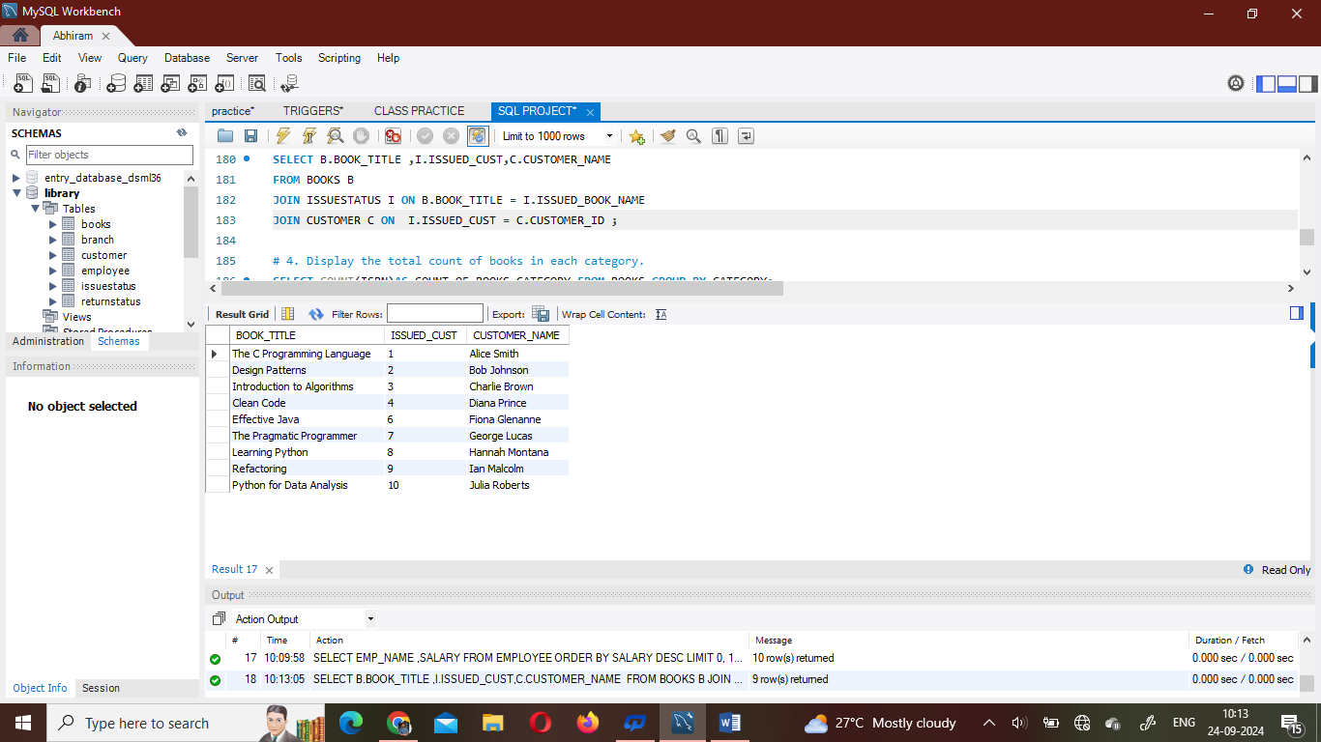

# 4. Display the total count of books in each category.

SELECT COUNT(ISBN)AS COUNT_OF_BOOKS,CATEGORY FROM BOOKS

GROUP BY CATEGORY;

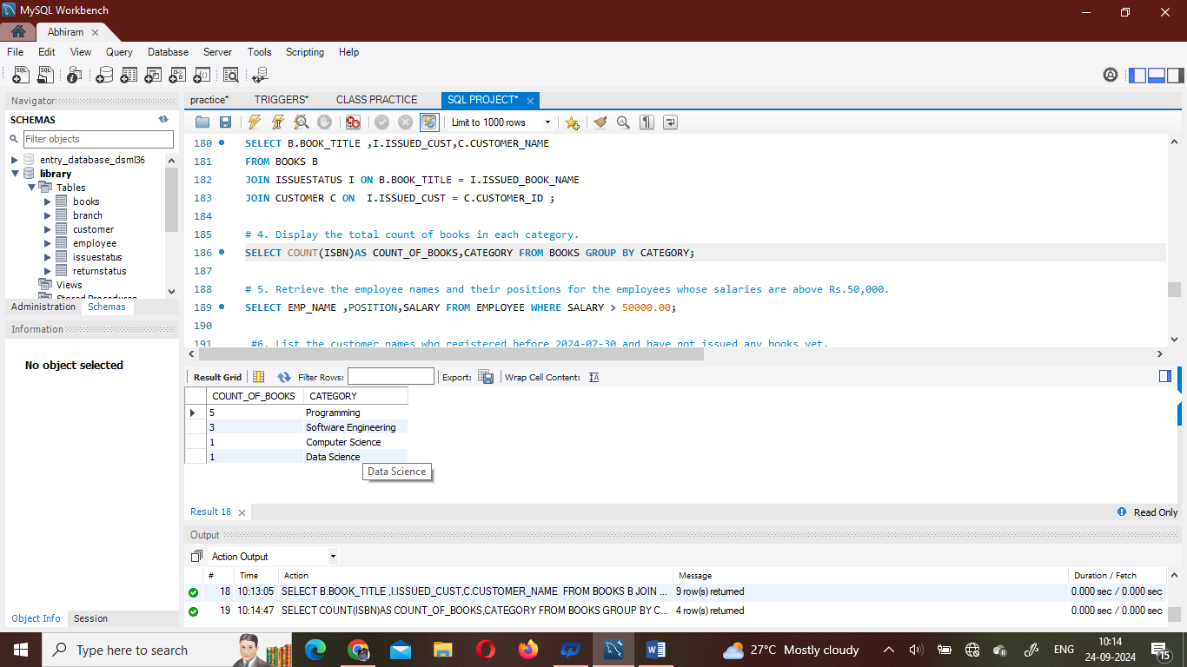

# 5. Retrieve the employee names and their positions for the employees whose salaries are above Rs.50,000.

SELECT EMP_NAME ,POSITION,SALARY FROM EMPLOYEE

WHERE

SALARY > 50000.00;

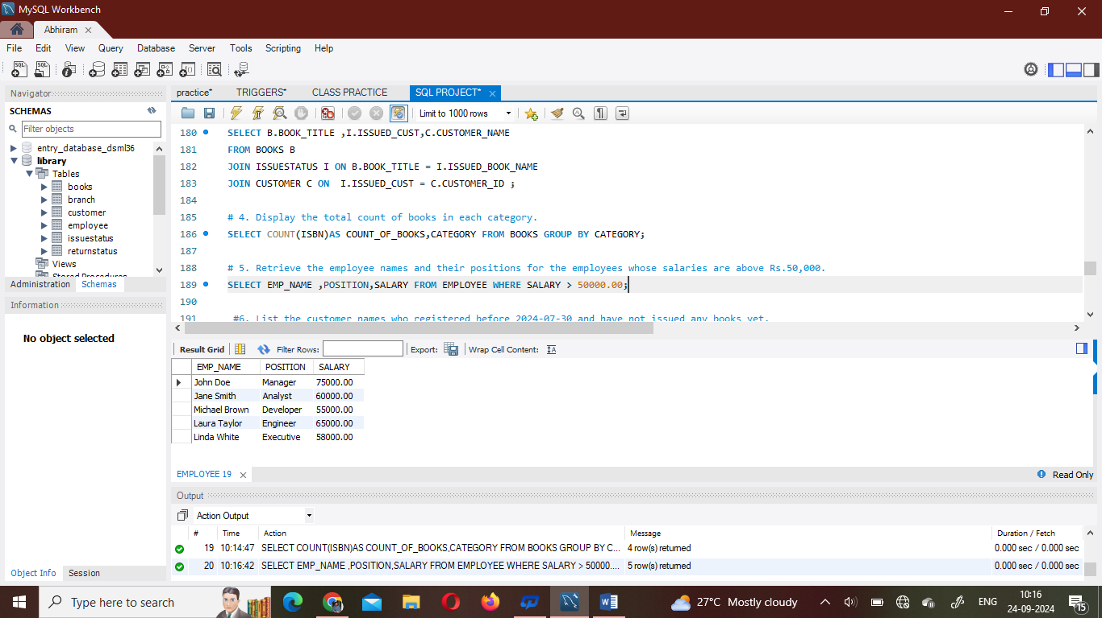

#6. List the customer names who registered before 2024-07-30 and have not issued any books yet.

SELECT C.CUSTOMER_NAME ,C.REG_DATE

FROM CUSTOMER C

JOIN ISSUESTATUS I

ON C.CUSTOMER_ID = I.ISSUED_CUST

WHERE C.REG_DATE < '2024-07-30' AND I.ISSUED_BOOK_NAME='';

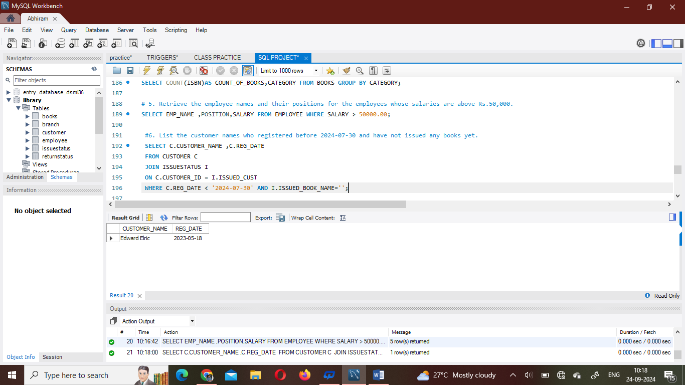

#7. Display the branch numbers and the total count of employees in each branch.

SELECT B.BRANCH_NO,COUNT(E.EMP_ID) AS TOTAL_EMPLOYEES

FROM BRANCH B

JOIN EMPLOYEE E

ON B.BRANCH_NO = E.BRANCH_NO GROUP BY BRANCH_NO;

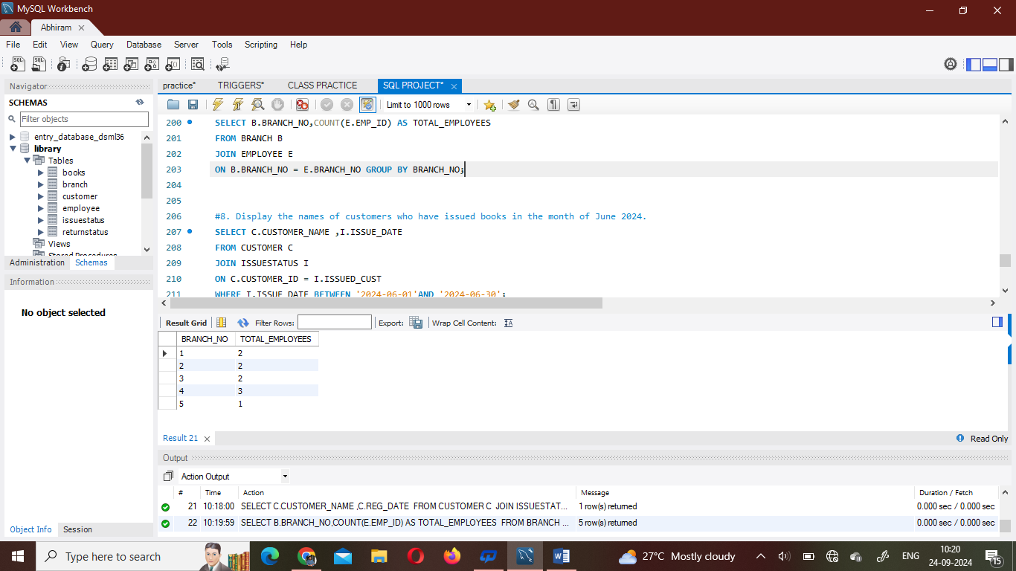

#8. Display the names of customers who have issued books in the month of June 2024.

SELECT C.CUSTOMER_NAME ,I.ISSUE_DATE

FROM CUSTOMER C

JOIN ISSUESTATUS I

ON C.CUSTOMER_ID = I.ISSUED_CUST WHERE I.ISSUE_DATE BETWEEN '2024-06-01'AND '2024-06-30';

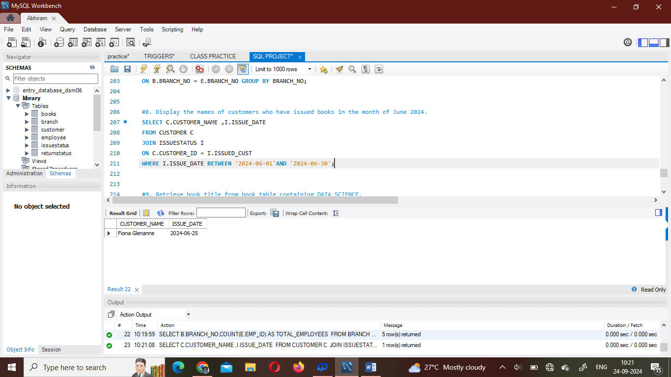

#9. Retrieve book_title from book table containing DATA SCIENCE.

SELECT BOOK_TITLE,CATEGORY FROM BOOKS

WHERE CATEGORY='DATA SCIENCE';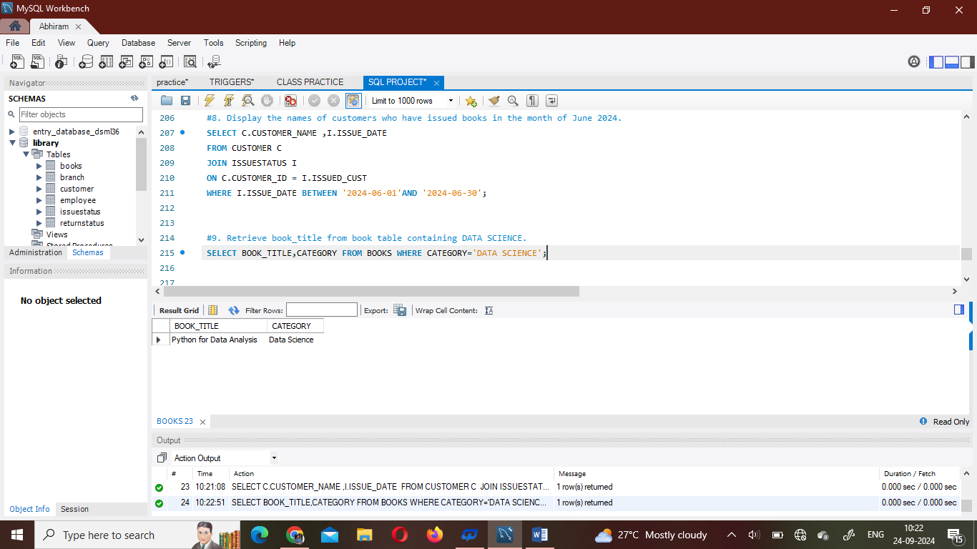

# 10.Retrieve the branch numbers along with the count of employees for branches having more than 2 employees.

SELECT BRANCH_NO ,COUNT(EMP_ID) AS EMPLOYEE_COUNT

FROM EMPLOYEE

GROUP BY BRANCH_NO HAVING COUNT(EMP_ID)>2;

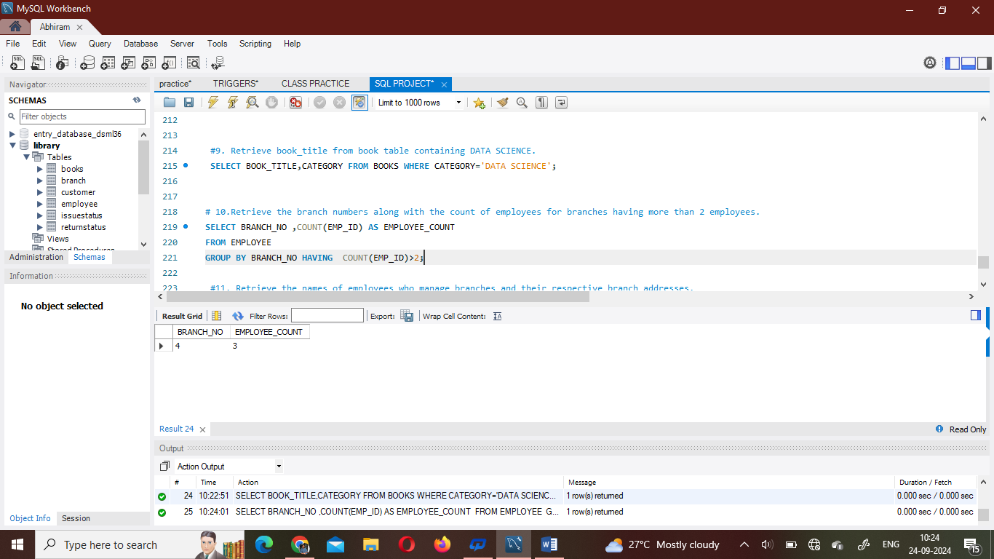

#11. Retrieve the names of employees who manage branches and their respective branch addresses.

SELECT E.EMP_NAME, B.BRANCH_ADDRESS

FROM EMPLOYEE E

JOIN BRANCH B

ON B.BRANCH_NO = E.BRANCH_NO

WHERE E.POSITION = 'MANAGER';

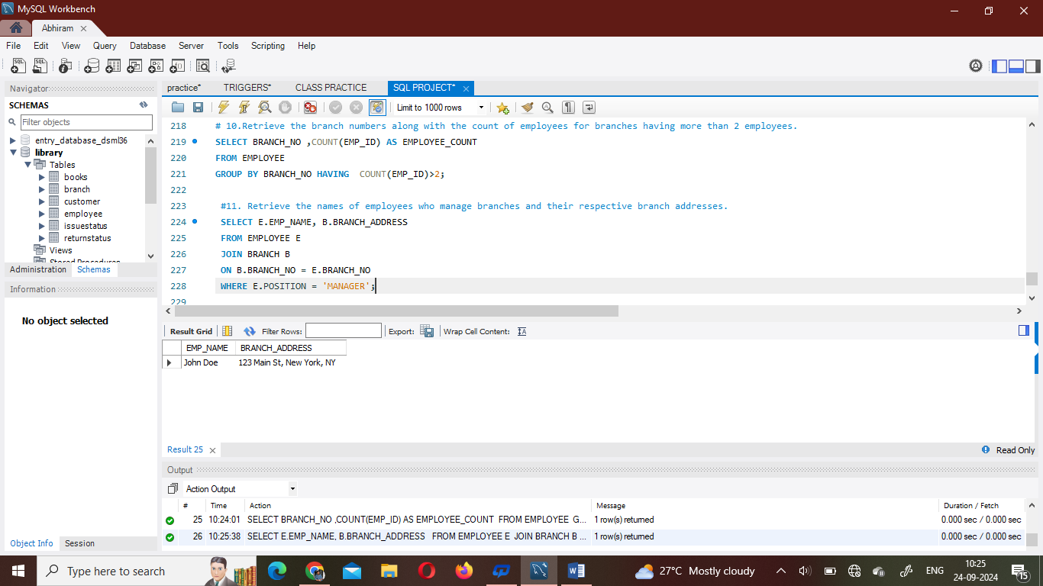

#12. Display the names of customers who have issued books with a rental price higher than Rs.7.

SELECT C.CUSTOMER_NAME, B.RENTAL_PRICE

FROM BOOKS B

JOIN ISSUESTATUS I ON B.BOOK_TITLE = I.ISSUED_BOOK_NAME

JOIN CUSTOMER C ON I.ISSUED_CUST = C.CUSTOMER_ID

WHERE B.RENTAL_PRICE > 7;

